Title: Transmission Mechanisms Theory
Subject: MTP
1. IDEA  2. POSSIBLE TRANSITION MECHANISMS  A. Investment (Baseline Keynes)  B. Consumption  a. Assumptions  b. Consumer lifetime utility  c. Budget Constraint  d. Optimize U under BC  e. Optimal Consumption Bundle (C1* and C2*)  f. Making Euler equation Linear  C. Exchange rate channel  D. Asset prices channel  a. 1 MP raises assets prices  b. 2 Asset prices raise AD  F. Credit ‘Channel’ i.e. The Financial Accellerator  a. Expanding Bank reserves  b. Expanding firms’ and consumers’ B/S (collateral) to overcome adverse selection and moral hazard  SUMMARY  APPENDIX | Transmission mechanisms transmit the policy stance to the real economic activity = policy goals (output, employment and inflation) by affecting intermediate targets.  First we will see how MP affects aggregate demand (intermediate target), then how AD affects the policy goals: Y, N, P  Consider the Goods market equilibrium (IS): AD = C + I(r) + G + NX. Now, if LR r increases:  I. Cost of borrowing $↑$ --> investment (firms and consumers) $↓$ --> AD $↓$  II. Adverse selection: those with the riskiest Inv projects are exactly the ones that are willing to payan higher i --> Bank credit-rationing --> I $↓$--> AD $↓$  Next steps will be used to define the Demand functional form  Two periods (t1 and t2, in t2 consumer dies). Asset: Bond.  Utility in t (log makes it increasing at a decreasing rate): U(C_{t}^{E}) = log(C_{t}^{E})  Lifetime utility: U(C₁E, C₂E) = log(C₁E) + βlog(C₂E), where 0 < β < 1 is the intertemporal discount factor (impatience)  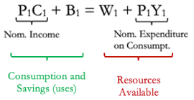  I. Budget t1:  P1: price level, B1: nominal bonds held, Y1: real income, W1: initial nominal wealth  II. Budget t2: P₂C₂ = W₂ + P₂Y₂ with W₂ = ( 1 + i₁)B₁  III: Merge BC ti by B: Intertemporal BC  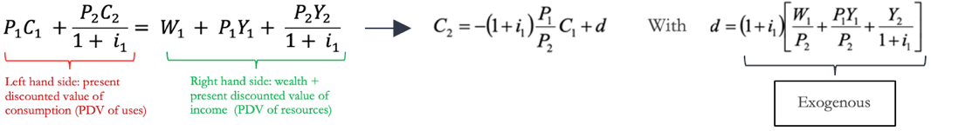  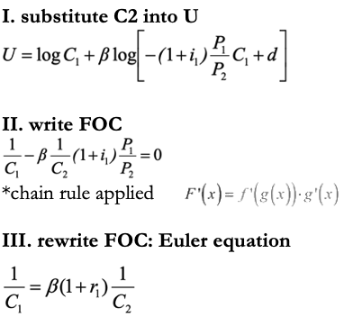  MB: saving 1u in t1 will give you +1 in consumption marginal Utility (MB) in t2 is the of U (1u * real rate / discount factor )  MC: give up consumption by 1u at t1 U at t1 will decrease by 1/C1  *it is also possible to rewrite our equation as $C1= \frac{C2}{β\left(1+r1\right)}$ or also as a ratio $\frac{C1}{C2}= \frac{1}{β\left(1+r1\right)}$  Key considerations: 1. only real rates matter 2. expectations count  Problem: you can smooth Cons only if you have full access to credit, if not agents will always consume what they dispose C_{t}^{H*} = $\frac{Wt Nt}{Pt}$  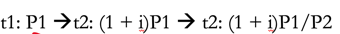  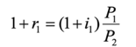  Note:  r1 is real interest rate, why? Look:  Just put FOC (Euler equation ) into BC and solve for C1*, C2* (C1, C2 and β endogenous)  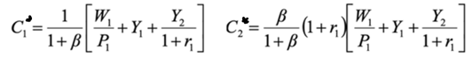  Note: Expectations about future events (including future monetary policy) matter for aggregate consumption demand  Problem: our Euler equation is non-linear we take log to make it linear  $C1= \frac{C2}{β\left(1+r1\right)}$--> log(c1) = log(c2) – log(β) – log(1+r1) $C1= C2-(r1-ρ)$, with log(C2) = c, - log(β) = ρ (this is > 0) and log (1+r) = r  Take now any generic pair of periods: $C= C^{e}-(r1-ρ)$  --> The Log linear Log linear Euler equation is our Log Linear dynamic IS curve  Assume now equilibrium in the goods market: c = y, then $y= y^{e}-(r1-ρ)$  Two main differences with the traditional IS curve:  1. A higher level of future expected output ye increases current output y due to consumption smoothing implicit in the FOC: a consumer prefers to smooth out consumption over time  2. The negative effect of r on y reflects the intertemporal substitution effect. When r is higher, the consumer prefers to save and invest savings in financial activities that appear today particularly attractive; thus, the consumer prefers to postpone consumption to tomorrow when maturing interests rates will generate a higher income; the consumer substitutes consumption today with consumption tomorrow; r represents the relative price of current consumption relative to future consumption  Increasing importance with growing internationalization  Expansionary monetary policy ↑, r ↓, E ↓ (national currency depreciation) NX ↑ AD ↑  MP --> Asset Prices --> AD  Step 1: Monetary policy affects real prices of financial assets (stocks, houses etc) in two ways:  A. Expansionary MP–> r on bonds ↓ equities or housing more attractive relative to bonds D ↑ P ↑  or put it differently, return on bonds ↓ Þ required return on stocks and housing↓ stock and housing prices ↑  B. Expansionary monetary policy aggregate demand ↑ dividends ↑ / r ↓ stock prices ↑  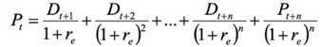  Step 2: Higher stock prices riaise AD in two ways:  A. Tobin’s q theory: Stock rpices –> Investment ---> AD  Tobin’s Q = (market value of firms) / (replacement cost of capital)  Replacement cost = cost of repurchasing all firm’s plants and equipment at market prices  Q = firm value on financial mkts / firm value on capital good mkts If Q is high, new plant and equipment capital is cheap relative to the market value of firms. That is, companies can issue equity and get a high price for it relative to the cost of the plant and equipment they are buying. So, expansionary monetary policy P ↑ Q ↑ I ↑ AD ↑  B. Wealth channel: Stock rpices –>Consumption –> AD  Consumers optimize lifetime resources which include human, real (Land) and financial wealth  Expansionary monetary policy ↑ P_{ASSETS} ↑ wealth ↑ C AD ↑  Not an alternative channel, but enhances the previously defined channels. Crucial to reduce difficulties to borrow (frictions) in the financial market. If monetary policy makes it easier for borrowers to borrow less frictions higher credit supply higher AD.  How to make borrowing conditions easier? i.e. How to reduce frictions?  Banks play a special role in fin mkts. Borrowers more subject to information prhey borrow from banks (large firms can borrow from the stock market). Expansionary MP, which increases bank reserves and bank deposits, increases the quantity of bank loans available for firms and consumers. Expansionary monetary policy ↑ bank deposits / reserves ↑ bank loans ↑ I↑ AD↑  Two sources of frictions:  I. Asymmetric information: Borrowers know return of their projects more than lenders.  II. Limited commitment: Borrowers cannot ensure to repay debt (default).  Lead to:  Adverse selection before a fin transaction occurs: lenders know there are some bad borrowers in the mkt, but can’t identify them (asymmetric info) --> will require higher interest --> bad borrowers will be more likely to accept the loan, as they are more incline to default (adverse selction).  Moral hazard after a fin transaction occurs: risk (hazard) that the borrower might engage in behavior that is undesirable for the lender  Solution: Collateral  I. reduces losses associated to default  II. reduces moral hazard (as now borrowers may lose their home Incentives of the borrower become aligned with those of the lender) Borrowing conditions depend on collateral/net worth of borrowers  MP raises collateral!  How the mechanism works: expansionary monetary policy PAssets ↑ net worth = Collateral ↑ adverse selection & moral hazard ↓ lending ↑ I ↑ / consumers’ investments in houses and durables AD ↑  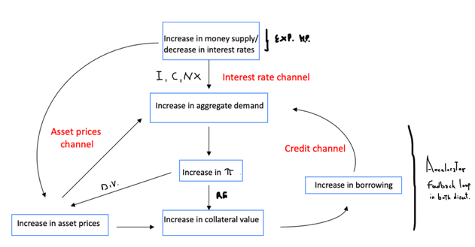  We have seen that what matters for investment decisions is the LR real interest rate (r)  Monetary authority controls the ST nominal rate (i)  How can CB control longer real rates by controlling short nominal rates?  Two facts explain the link:  A. St nominal rate affects the ST real rate  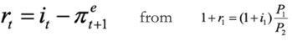  B. ST real rate affects LT real rate  Expectation hypothesis of the term structure: the long-term interest rate equals the average of the expected future short-term rates  